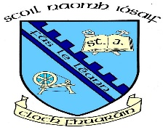

Concerts and Christmas Dinner December 2022 Parent Information

Christmas Dinner will be on Friday 9th December – Children traditionally go home early on this day. We will forward pick up times shortly.
Day/date | Class/Classes | Time
Monday 12th | Choir Carol Service  For parents of the children in the choir | 2.00 – School Assembly Hall
Tuesday 13th | Nursery | 11.00 – School assembly Hall
Wednesday 14th | P6/7 Evening Performance | 7.00 in St. Paul’s High School
Thursday 15th | P1 and P2 | 11.00 for P1 – School Assembly Hall  11.20 for P2 – School Assembly Hall
Friday 16th | P3 and P5 | 11.00 for P3 – School Assembly Hall  11.20 for P5 – School Assembly Hall
Our school hall has a limited seating capacity and depending on the size of each class/year group there may also be a limit on the number of family members who can attend each concert.
Please note that Primary 4 children will hold their special music concert later in the year as part of the Music Pathways Programme.

