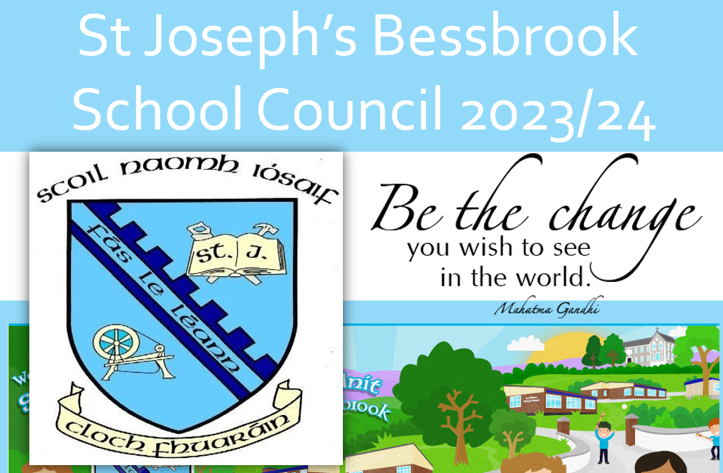

**What to include?**

* Introduce yourself.
* What qualities do you have that would make you a good candidate for the school council?
* What have you done in the community/ school or home that you could use as experience for the school council?
* What changes would you recommend in school?
* What charities could we fundraise for, ideas of how we could fundraise?

**What makes a good presentation?**

Introduce yourself.

• Clear structure

• Short/concise

• Keep presentation simple

Presentation:

• Use visual aids/ PowerPoint/ iPads

Image

• Dressed appropriately/ Neat uniform

• Good use of body language

• Confident appearance

Voice

• Clear and audible voice

• Suitable pace of speaking – not too fast

Audience

• Address your audience

• Involve the audience

**Presentations will take place on Tuesday 17th of October.**

**Results will be announced on the Thursday 19th of October.**